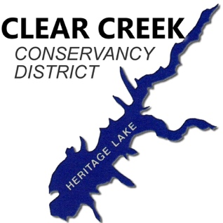
Sewer Lateral Inflow & Infiltration Inspection Report
Private Side, From Utility Easement Up To
And Including Structure Plumbing

To be completed by a Licensed Plumber, and submitted to Clear Creek Conservancy District via USPS or email.
Clear Creek Conservancy District
P.O. Box 286 billing.clearcreek@tds.net
Greencastle, IN 46135

Property Information
Property Owner’s Name: _____________________________ Phone #: __________________
Site Address (Neighborhood & Lot # Only): _________________________
Owner’s Mailing Address: Same as Site Address
Street Address: _______________________________________________________________
City: _____________________________________ State: _________ Zip: ________________

Inspector’s Information
Company Name: ____________________________ Company Phone #: __________________
Inspector’s Name: _________________________ Inspector’s Phone #: __________________
License #: ________________________________

General Observations
Home Foundation: Slab Crawl Space Basement
Number of outside sewer lateral cleanouts: ______ Properly capped? Yes No
Basement/crawlspace sump pump(s) properly discharge outside? Yes No No Sump
Sewer ejector pump in use? Yes No
Number of structures at address served by the private sewer lateral (Including Home): ______

CCTV Sewer Inspection (Optional)
Completed camera inspection full distance (from home to main sewer connection)? Yes No
Total linear feet inspected: ______
Sewer Video Discovery Notes (e.g. cracked pipe, open joints, root or cable breach, unknown Wye/Tee entry) ____________________________________________________________________________
____________________________________________________________________________
____________________________________________________________________________
____________________________________________________________________________

Additional Inspection Notes (Optional) If applicable, please list all non-compliances. ____________________________________________________________________________
____________________________________________________________________________
____________________________________________________________________________
____________________________________________________________________________
____________________________________________________________________________
____________________________________________________________________________

Drawing/Sketches (Optional)

Inspection Results
Property has been verified as having no illegal connections, including sump pumps, roof gutters, foundation/perimeter drains, open loop heat pumps, etc.; entering the sanitary sewer system. Yes, passes inspection No, fails inspection

Note: If initial inspection did not pass, please submit BOTH this failed inspection AND a new passing inspection to Clear Creek Conservancy District once corrections have been made. This allows us to document I/I improvements to the collection system.

The information submitted herewith complies with all requirements set forth by the Clear Creek Conservancy District. I declare under penalty of perjury that all information submitted here is true and correct to the best of my knowledge, and applies to the listed address only.

Inspector’s Signature: ___________________________________ Date: _________________

